Dark Fantasy

Characters: Knight, Demons, King Reaver, Alexandrius

1. Knight finds a magical sword around a pile of dead people

2. Fights and kills first Demon

3. Pick between 3 kingdoms, Tirion, Areth and Xijing.

4. Fights many demons and humans strengthens the magical sword

5. Reaches the demon blacksmith domain

6. Fight demons in sword.

Tirion

European setting

In castle Krass the knight will fight many other knights and magicians and occasionally demons. Reaches the kings crown. The knight wear it and is able to access more of the castle. If you do not put on the crown the exit to the castle leads into the demon blacksmiths domain you enter it and it kills you.

Areth

Mayan setting

In the ancient jungles of Tatakall the knight maneuvers thru to find key to open door of cemetery and encounters the demomancer. Using gem and going to the end of the area results in bowing to the demon blacksmith, and a game over.

Xijing

Asian Setting

Competition of past and present, Kingdom. Perfect mix of Demons and Humans.

ShangQu: The Knight gets embroiled in a conflict between two warlords.

PingQu: The Knight may come here but can only do side quests until clearing ShangQu.

XiaQu: The Knight has to come here multiple times through doing the missions in ShangQu and PingQu. When both are cleared the Knight can do a ritual to drink demon blood and clear the Miasma of the area. If the player drinks all the Demon Blood they become overwhelmed after killing the third area boss, the Demon Blacksmith comes to you, declaring yourself ready.

Demon Dimension

Dream Setting, only one region exists that leads directly to Demon Blacksmith. Player comes to Blacksmith and initiates either a Battle or Game Over and the final boss.

Losing once = Game Over, reset from beginning

Scenes:  
**Intro:**

Mystery sword: Hello mysterious warrior what will you be doing now that you have me?

Knight: Who is speaking?

Ms: It’s me in your hand.

K: How can that be.

Ms:That is the power of the blade, i can guide you with the knowledge of years of combat and

wisdom but i only ask you of one thing.

K: What is it?

Ms: There is a great evil coming and you can only beat it with my help.

K: I don’t know if that’s something i can do, I’m not fit for a hero’s journey

Ms: You sound like a wounded soul, how can you achieve greatness and regain your status if

you don’t fight for what is righteous and true? What will your comrades think of you when you come back with nothing but your tail between your legs when you could be their hero, their

Inspiration.

K: That won’t happen i came on this mission to redeem myself for my king my countrymen and

my family.

Ms: So do you accept the journey, the hero’s journey to be the chosen hero of legends?

K: I accept!!!!!!!!!!!

Ms: Good here’s what you need to defeat, The demon Blacksmith.

**Tirion:**

A dense fog exits the land as you walk through a light drizzle, it is nighttime and the moon glints through fleeting clouds high over the kingdom of Tirion. You can see, as you strolled, that most is abandoned, or downtrodden. Not abandoned yet a shadow of it's former glory; castle Krass approaches massive and foreboding with terror which your courage must brave to survive and claim the legendary crown.

Enter the [[First Level Of Castle Krass]], [[High Wall of Castle Crass(Base)]] or [[Dark Psalm Garden]], You've come this far after all.  
  
High Wall of Castle Crass(Base):  
The High Wall's oppressive exterior prevents further travel forward, it's black bricks seem as if charred in exterior, but this is simply optical illusion, it seems an unnatural feature foreshadowing a greater evil at work. The land used to be patrolled telling from a surrounding beaten path just in your view down the hill, you see some estrewn shields, the remains of barricades, a battle has occurred here though how long ago is not apparent.

You may hop down onto the [[Crimson Path]], enter [[First Level Of Castle Krass]] or return to [[Tirion]]

Crimson Path  
The High Wall now seems to almost lurch over you in height, though this is a product of fear, you notice the massive path is the dressed in the spoils of war, yet before you can gain your bearings, an enemy approaches quickly.

MS: That man has the crown that you need to defeat the demon blacksmith.

K: With you i can do anything, i've never felt this confident and powerful in my life.

MS: I hope that translates to a victory

K: It will!!!!!!!!!

BK: It won't be that easy i've encountered many warriors who met their fates here, so trust me this will be the fight of your life.

Battle the [[Black Knight]]

Black Knight  
Knight Lv$lv

HP = $hp

Att = $att

Black Knight

HP = $enemyHP

Att = $enemyAtt

Def = $enemyDef

(if: $hp is 0)[[Gameover]]

(else:)[(if: $enemyHP is 0)[[[Continue|Maroon Path]]](else:)[

[[Attack Black Knight]]

[[Defend against Black Knight]]

Defend against Black Knight

Attack Black Knight  
Maroon Path (this is after victory?)  
With the Knight felled, you stand triumphant. You loot the dead Black Knight, and may proceed to the [[First Level Of Castle Krass]]

**Areth:**

As you enter into the jungles of Areth you notice the plants are very wild and different from home. The jungle is full of loud exotic animals that screech as you get close, as if traumatized by your sight. The air is wet and moist and you can feel the heat and moisture on your armor as you cut thru the dense jungle and push past shrubbery you reach a section of the jungle that looks deliberately cut out and setup with only one entrance and different turns but nothing straightforward.

MS:It appears you've entered a maze of some sorts.

K: Seems i have to navigate it anyway

MS: I sense enemies so be careful. Also you need to find, the gem of areth, that will increase your strength for your upcoming fight

After maze and battles (This is how the maze gonna work)

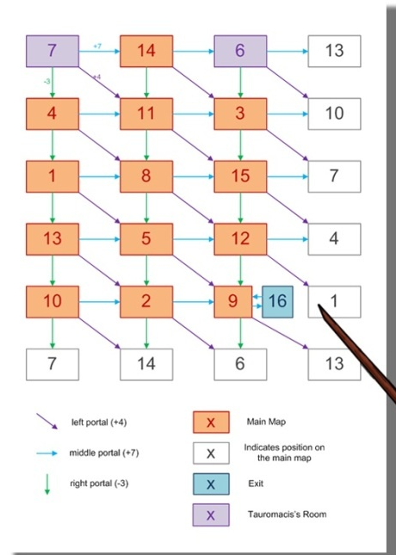

You see a demonmancer with the gem of areth, he summons many demons to fight you.

MS: You have the skills and power to fight many demons, don't be discouraged by the numbers i believe in you.

K: Easy for you to say

DM: Stupid knight you can't win against me and my demons with just a puny sword.

After demons and boss fight

MS: Will you use the gem of areth or will you hold onto it till later?

**Xijing:**

Xijing, the twilight city of Xijing is the home of mixed breeds, humans and demons. This area is also in constant war struggles. Tales of legendary Samurai who single handedly won wars and battles come from this region and the affinity for demons is unparalleled. As the knight walks down the dirt road path the smell of blood overcomes the senses in a way that can not be comprehended. The knight notices a loud screaming and banging of metal and sees people fighting.

MS: We need to get passed these people without getting noticed

K:I don't think that's going to happen.

MS: We don't even have choice they see me, guess it's time to fight

After Fight

Chooses to go to ShangQu, PingQu or XiaQu:

Put thru random quests:ShangQu: The Knight gets embroiled in a conflict between two warlords. After defeating them the knight frees the slaves from ShangQu and PingQU from the two warlords after defeating them.

SL: Thank you for saving us, i wish there was a way i could repay you.

K: It's ok i came here to find a very dangerous demon do you know where it is

SL: Yeah but you have to do a ritual and transcend your humanity to even see it and from what i can tell you're pretty close to that

In PingQu the night speaks to the both are cleared the Knight can do a ritual to drink demon blood and clear the Miasma of the area. If the player drinks all the Demon Blood they become overwhelmed after killing the third area boss, the Demon Blacksmith comes to you, declaring yourself ready.